**Repair board electronics main rules must be followed**

1. I publish my new method for the first time, explaining everything you need in detail. Professionalism. Easily repair electronic devices

<https://www.youtube.com/watch?v=ZZNlQtJH_JA&ab_channel=%D8%A7%D9%84%D9%85%D9%86%D8%AA%D8%B5%D8%B1%D8%A7%D9%84%D9%83%D8%AA%D8%B1%D9%88%D9%86%D9%8A%D9%83>

The problem with this card no output voltage 14v

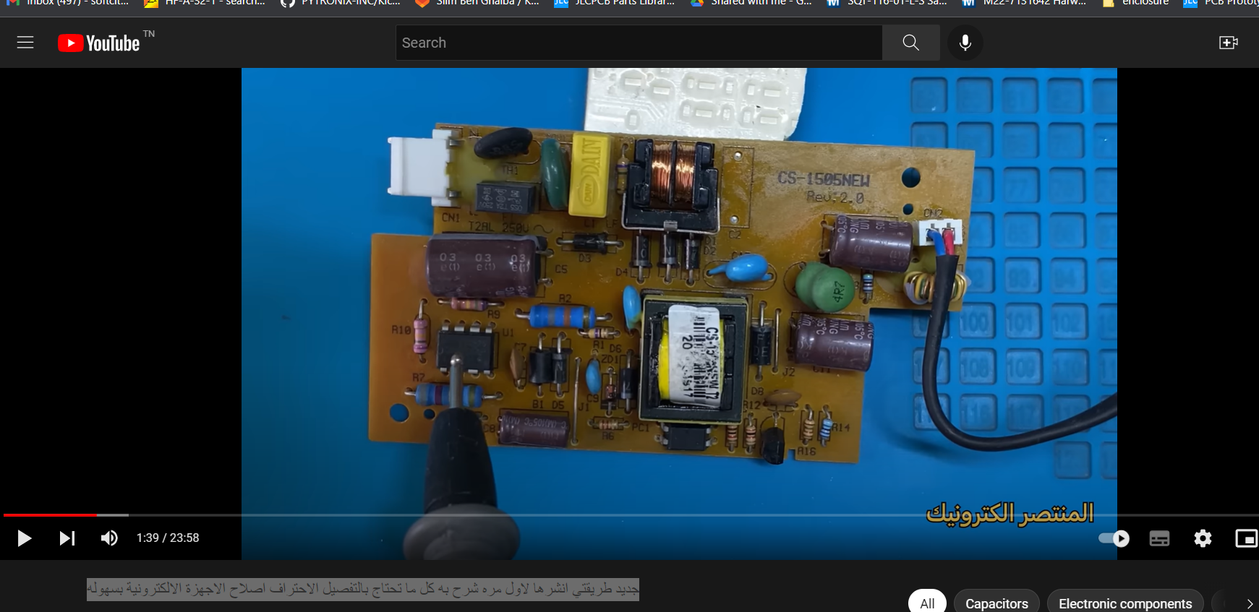

tips followed to rest the board

1. test the voltage output from Capacitor 300v
2. the IC from PWM not polarize from 12v
3. test the output from capacitor near the IC power

**solution from repair**

two resistors to minimize high voltage to low voltage to power IC are defective replace them

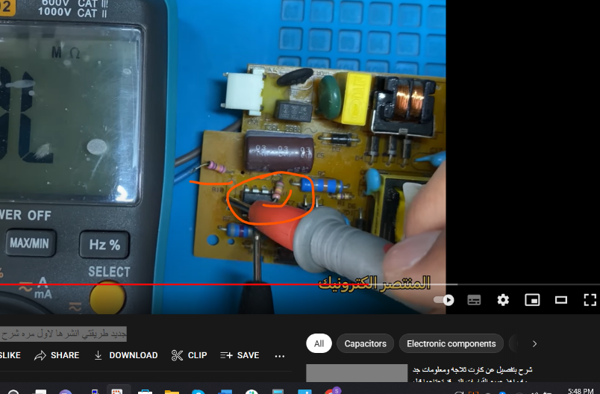

<https://www.youtube.com/watch?v=6A1z-D3JhLk&ab_channel=%D8%A7%D9%84%D9%85%D9%86%D8%AA%D8%B5%D8%B1%D8%A7%D9%84%D9%83%D8%AA%D8%B1%D9%88%D9%86%D9%8A%D9%83>

* change the exact reference from relay because charge the motor or compressor

1. Professional repair SAMSUNG washing machine and refrigerator cards 7.0KG WF0690NXW DC41-0015

<https://www.youtube.com/watch?v=azJTjrcsFwA&ab_channel=%D8%A7%D9%84%D9%85%D9%86%D8%AA%D8%B5%D8%B1%D8%A7%D9%84%D9%83%D8%AA%D8%B1%D9%88%D9%86%D9%8A%D9%83>

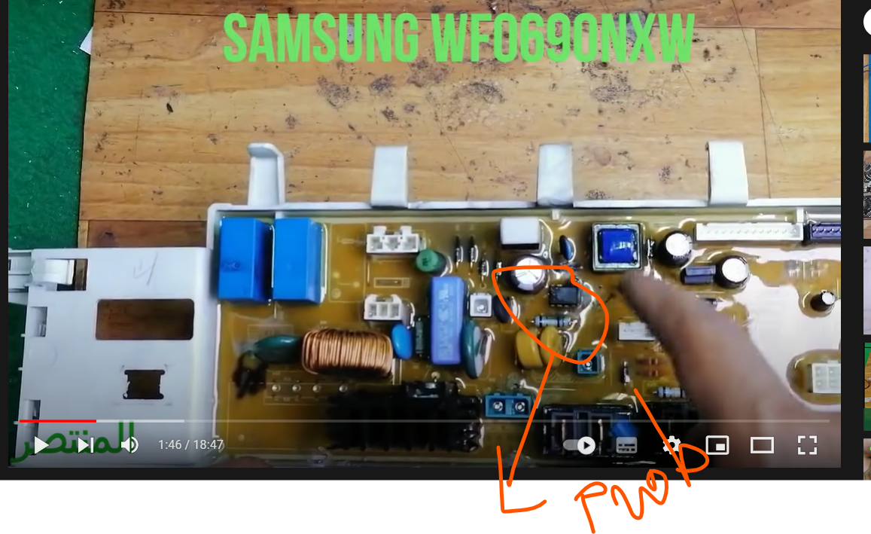

1. washing machine works not long so need to repair IC of power is heating when is heat cut off the power and machine off
2. replace IC circuit

<https://www.youtube.com/watch?v=Lm8M2zc7tPA&ab_channel=%D8%A7%D9%84%D9%85%D9%86%D8%AA%D8%B5%D8%B1%D8%A7%D9%84%D9%83%D8%AA%D8%B1%D9%88%D9%86%D9%8A%D9%83>

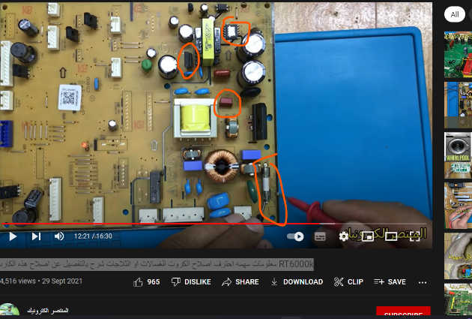

1. **invertor**